**IST 263 Project Milestone 6 – First Draft Using CSS**

**Name**: Annie Zhou

**Description:**  
I would like to make a website about how to correctly feed a dog. This includes some introduction of dogs and dogs with characteristics of dogs with different body types,and tips for small things in daily lives about dogs. It will also includes a page of examples of problems and how people fixed them.

**What is the url of the page you choose to work on for this part?**

<https://github.com/wuhdbwl/czhou42-SU/blob/main/Project%206/Project_home.html>

**Paste a screen shot of the wireframe you created for this page below.**

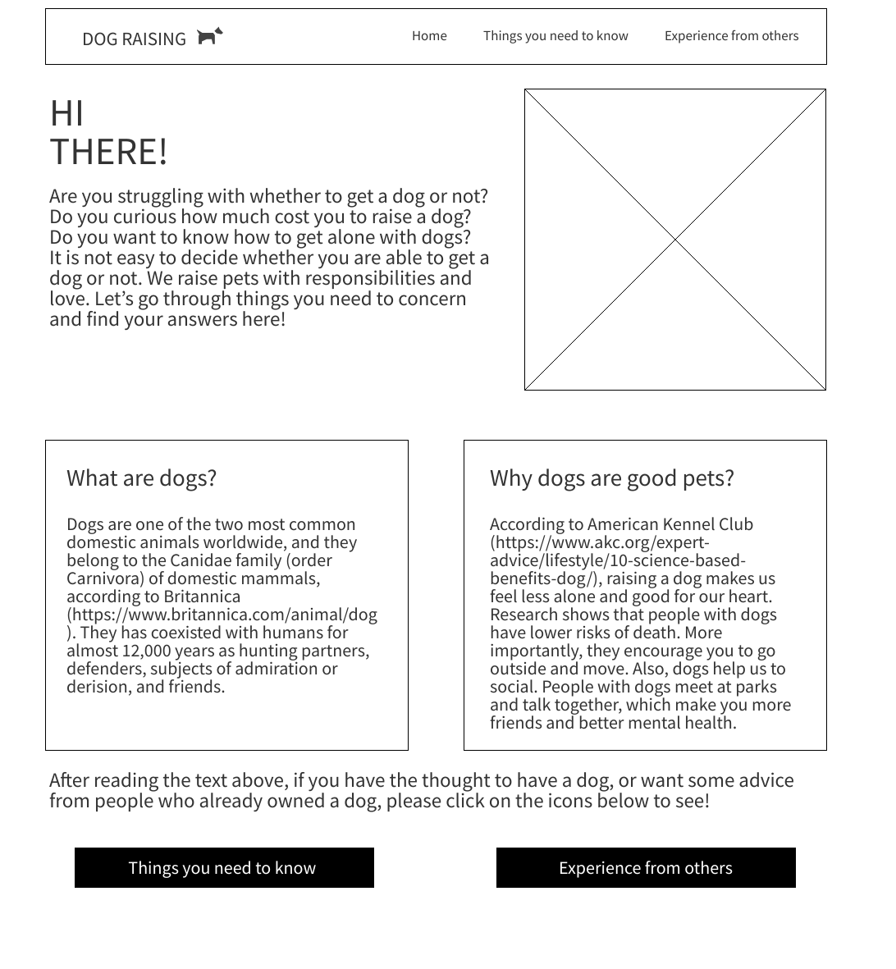

**Provide the URL of the WAVE checker for this page below.**

**[https://wave.webaim.org/report#/https://github.com/wuhdbwl/czhou42-SU/blob/main/Project%206/Project_home.html](https://wave.webaim.org/report#/https:/github.com/wuhdbwl/czhou42-SU/blob/main/Project%206/Project_home.html)**

**Provide the URL of the HTML validator for you page below.**

**<https://validator.w3.org/nu/?doc=https%3A%2F%2Fgithub.com%2Fwuhdbwl%2Fczhou42-SU%2Fblob%2Fmain%2FProject%25206%2FProject_home.html>**

**If something went wrong in this part, describe what happened and how you can fix it moving forward.   
Examples of problems could be, page isn’t responsive, page doesn’t look like wireframe, etc.**

**I think it is my computer’s problem that I failed to get these through the whole semester.**